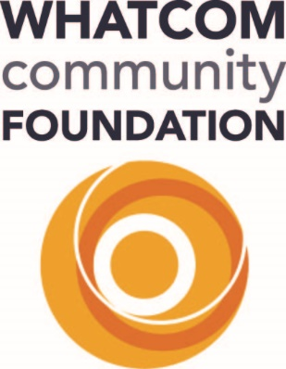

2023 Project Neighborly FAQ’s
Grant Application timeline – Application February 1, 2023 through April 10, 2023 by 4pm
What is the intended purpose of the grants?
Neighborly grants are intended to spark ideas and make the necessary resources available to bring them to life. We believe that your enthusiasm for more neighborly communities, from the water to the mountains and between our international and county borders, combined with your energy and ingenuity will result in more area residents being neighborly – kind, considerate and helpful – to everyone they meet. If we’re successful, ultimately that will mean more and better relationships communitywide, better ideas and decisions, and, a happier, healthier place for everyone.
Maximum grants of up to $5,000 will fuel inspiring, actionable, relevant projects that develop a sense of community. The Community Foundation is investing over $100,000. You can help grow the possibilities pool by making a gift online or mail your contribution to: Whatcom Community Foundation, 1500 Cornwall Avenue, Suite 202, Bellingham, WA 98225. Proposals may include activities such as group projects, art, performance, recreational activities, events, rental of recreational and art facilities, supplies, gatherings, learning initiatives, etc. Grant funding is available for the expenses involved in the creation and execution of the proposed project.
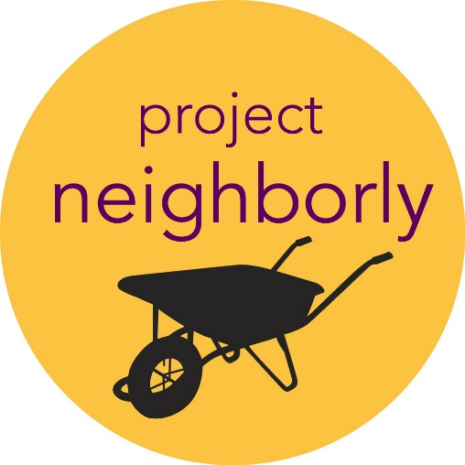
Who can apply?
This grant is for people with great ideas of how we can all become better neighbors by connecting people who would not normally come together. Applicants supporting projects or programs within Whatcom County. Eligible recipients are organizations with a valid letter from the IRS recognizing the applicant as a 501(c)(3) organization; Native American tribal agency; public or religious institutions; and projects with an approved Fiscal Sponsor.*
We hope that Neighborly grants will attract ideas from all corners – granges, neighborhood associations, faith organizations and student groups as well as nonprofit organizations, Native American tribes and local government. Never applied for a Community Foundation grant before? Wonderful! We look forward to getting to know you.
*A fiscal sponsorship is a formal arrangement in which a 501(c)(3) public charity sponsors a project that may lack exempt status. This alternative to starting your own nonprofit allows you to seek grants and solicit tax-deductible donations under your sponsor’s exempt status.
Project Period will be from June, 2023 through May 2024.
Below are a few examples as inspiration, the key is asking yourself, “Will this idea help start conversations with unusual suspects (i.e., people I otherwise might not have approached)?”
Block Party (regardless of the size of your block!) – Whether there is a field or a few feet between you and your nearest neighbor, organize a block party. Ask every adult to bring a picture of themselves when they were a kid and try to figure out who’s who. Organize activities for kids. Break bread together and get to know one another.
Story Exchange – Grab a smart phone or a video camera and learn more about someone you don’t know well (or maybe at all yet). It could be someone who lives near you, someone you know from work or school or somewhere else. Interview them and record the conversation. We’ll post the video on the Project Neighborly webpage.
Modern Barn Raising…or Spiffing – Is there a grange or another community center near you that needs some tending? Is there a place that could use some trees? Pick something and organize a work party to improve your place and meet the people in it!
Skill Share – Organize an event where people can share and/or learn the skills that already live in your community – woodworking, food preservation, beekeeping – anything you and your neighbors know how to do.
Put it in Writing – This is a great one for those of us who are more introverted. Come up with a public art project where people can contribute their ideas about what makes your place special or something they want to see improved. It could be a mural or a big makeshift chalkboard in your school, class, community center, grocery store, grange or church where people can answer a question like:
Before I die…
I stand for…
Community means…
What’s your dream…
Make a wall of happiness – ask people what makes them happy
These are just a few example to get your wheels turning. Be creative! The sky’s the limit (within budget, of course).
What will be considered for funding?
A wide variety of projects could fit these parameters but preference will be given to ideas that:
- Are specific and relevant for Whatcom County: Does the project clearly identify a specific and relevant need, locale, and audience? Does it address who is involved, where the activities will happen, and why is it important?
- Bring diverse people together (how can you bring people together who don’t normally interact?)
- Inspire a sense of community by uniting people around a common goal
- Build on community strengths or offer exciting ideas to address community challenges
- Present a realistic and achievable plan to accomplish the project
- Are supported and led by people who are trusted or are becoming recognized within their community as connectors and leaders
What won’t be considered for funding?
We will NOT consider funding projects that:
- Whatcom Community Foundation believes no person should be excluded from agency service, employment or volunteer participation, and will not fund organizations or programs that engage in discrimination on the basis of age, race, national origin, ethnicity, gender identity, disability, sexual orientation political affiliation or religious belief, or for any other discriminatory reason.
- Include purchases or payments for personal use (i.e. no rent money, car payments, laptops, etc.)—occasionally equipment purchases or contract labor may be considered (see below)
- Support the general operating, program, capital, or capacity-building needs of established non-profits
- Do not explain clearly how the funding will be used, how the project will be implemented, and how it will benefit the community and bring it together
- Seek sponsorship for a recurring event or fundraiser
- Seek support for a capital building endeavor
- Seek funding for individual scholarships
Can funding be used for equipment purchases and contract labor?
A grant might be used to fund an equipment purchase if:
- The applicant has investigated the availability of the item in the community and has determined that it is not available from a resident or institution in the neighborhood for use in the project.
- The applicant has explored the option of renting the equipment and this is not possible.
If both borrowing and renting are not feasible, the applicant must demonstrate that an equipment purchase would advance the mission of the project and align with the grant intent. The applicant must identify how they can make this equipment available to others for future charitable projects in the community.
Grants may fund contracted labor if the success of the project requires professional expertise that is not available in the community.
Grant Application timeline – February 1, 2023 through April 10, 2023 at 4pm
How will grant awards be announced?
All applicants will be notified via email by the end of May about funding decisions.
How will grant awards be announced?
All applicants will be notified by email about funding decisions and distribution process.

